Day 386 — Data Visualization
Complete Revision Notes | Matplotlib • Seaborn • Chart Selection
Learning goal: understand what each chart communicates, create and customize plots in Python, compare Matplotlib with Seaborn, and build a small student-performance visualization project.

1. What is Data Visualization?
Data visualization is the graphical representation of information and data. Charts and plots turn rows of numbers into visual patterns that are easier to inspect, compare, explain, and communicate.
A good visualization answers a question. It should make the important pattern visible without distorting the data.
Purpose | What it helps us do | Example
Understand trends | See how a value changes in an ordered sequence | Monthly revenue
Compare categories | Compare values across groups | Marks by subject
Study relationships | See whether two numerical variables move together | Study hours vs marks
Inspect distributions | Understand spread, concentration and skew | Exam-score distribution
Detect unusual values | Identify observations that deserve investigation | Unusually high salary

Typical visualization workflow
Raw dataset
|
v
Understand the question
|
v
Clean and prepare data
|
v
Choose a suitable chart
|
v
Create and customize the plot
|
v
Interpret the result and communicate findings

2. Matplotlib Fundamentals
Matplotlib is a Python plotting library. Its pyplot interface provides familiar functions for creating figures and charts. It offers detailed control over axes, labels, colors, markers, legends, layouts, and saving.

Installation and import
pip install matplotlib

import matplotlib.pyplot as plt

A figure is the overall drawing area. An Axes object is the region where an individual chart is drawn. A figure may contain one or many Axes.

Basic plot
import matplotlib.pyplot as plt

x = [1, 2, 3, 4, 5]
y = [10, 20, 15, 30, 25]

plt.plot(x, y)
plt.title("Basic Line Plot")
plt.xlabel("X values")
plt.ylabel("Y values")
plt.show()

Function | Purpose
plt.figure() | Create or configure a figure
plt.plot() | Draw a line plot
plt.bar() / plt.barh() | Draw vertical / horizontal bars
plt.scatter() | Draw individual points
plt.hist() | Draw a histogram
plt.boxplot() | Draw a box-and-whisker plot
plt.title() | Set the chart title
plt.xlabel() / plt.ylabel() | Label the axes
plt.legend() | Display labels for plotted series
plt.grid() | Show grid lines
plt.xlim() / plt.ylim() | Set visible axis limits
plt.subplot() / plt.subplots() | Create multiple plot areas
plt.tight_layout() | Improve spacing between plot elements
plt.savefig() | Save the figure to a file
plt.show() | Display the figure

3. Line Plot
A line plot connects observations with line segments. It is especially useful when the horizontal axis has a meaningful order, such as time, distance, or a sequence of experiments.
Use it for monthly sales, daily temperature, stock-price history, website traffic, or marks across semesters. Avoid connecting unrelated categories when the connecting line suggests a continuous trend that does not exist.
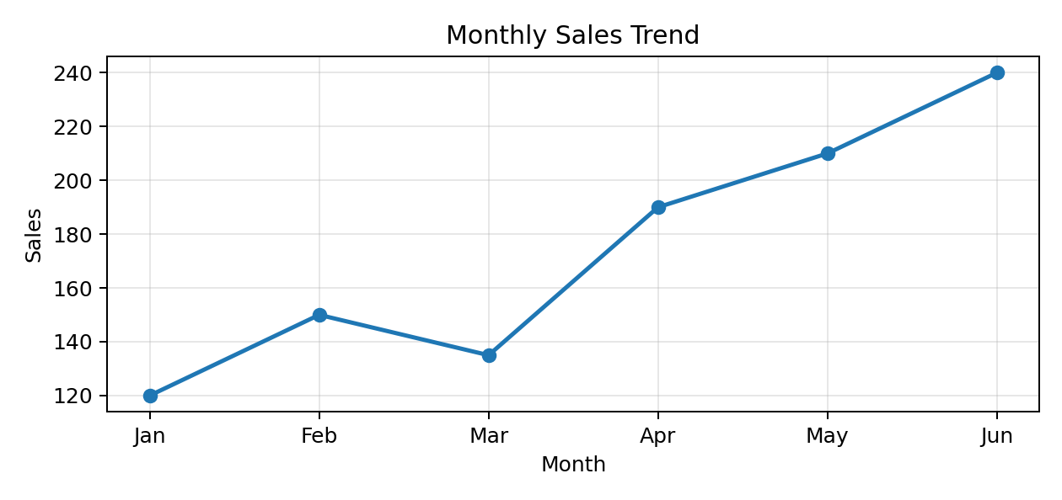
Figure 1. Example line plot showing a monthly sales trend.

Example: monthly sales
import matplotlib.pyplot as plt

months = ["Jan", "Feb", "Mar", "Apr", "May", "Jun"]
sales = [120, 150, 135, 190, 210, 240]

plt.figure(figsize=(8, 4))
plt.plot(
months,
sales,
color="royalblue",
marker="o",
linestyle="-",
linewidth=2,
label="Sales"
)

plt.title("Monthly Sales")
plt.xlabel("Month")
plt.ylabel("Sales")
plt.legend()
plt.grid(True, alpha=0.3)
plt.tight_layout()
plt.show()

Parameter | Meaning
color | Line color
marker | Symbol drawn at each observation, e.g. 'o', 's', '^'
linestyle | Line pattern: '-', '--', ':', '-.'
linewidth | Line thickness
label | Text used by the legend

4. Bar Plot
A bar plot compares numerical values across discrete categories. The length or height of each bar represents the value for that category.
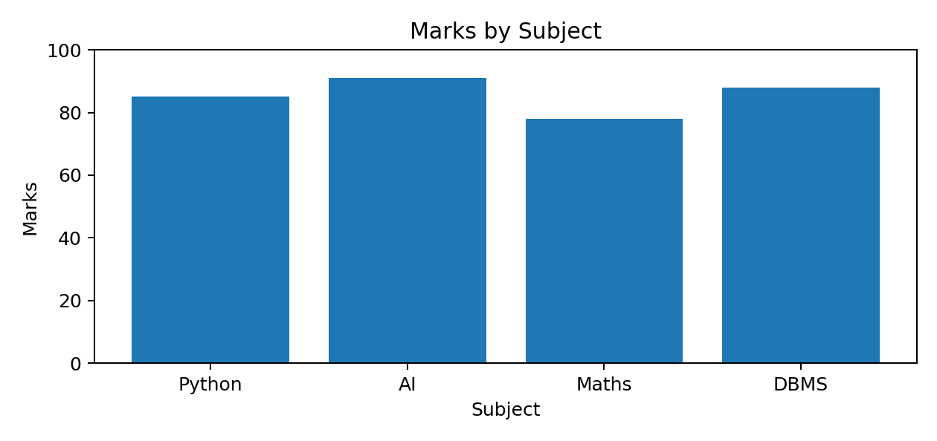
Figure 2. Example bar plot comparing marks across subjects.

Common bar-chart forms
Type | Description | Example
Vertical | Bars extend upward | Marks by subject
Horizontal | Bars extend sideways | Ranking long product names
Grouped | Several bars sit side by side for each category | Python vs AI marks by student
Stacked | Subcategory values are stacked into one bar | Sales split by product type

Vertical and horizontal bars
import matplotlib.pyplot as plt

students = ["Aman", "Rahul", "Simran", "Harshit"]
marks = [85, 90, 78, 95]

plt.bar(students, marks, color="skyblue")
plt.title("Student Marks")
plt.xlabel("Student")
plt.ylabel("Marks")
plt.ylim(0, 100)
plt.show()

# Horizontal version
plt.barh(students, marks)
plt.xlabel("Marks")
plt.ylabel("Student")
plt.title("Student Marks — Horizontal")
plt.show()

Grouped bar chart
import numpy as np
import matplotlib.pyplot as plt

students = ["Aman", "Rahul", "Simran"]
python_marks = [80, 90, 75]
ai_marks = [85, 88, 92]

x = np.arange(len(students))
width = 0.35

plt.bar(x - width / 2, python_marks, width, label="Python")
plt.bar(x + width / 2, ai_marks, width, label="AI")

plt.xticks(x, students)
plt.xlabel("Students")
plt.ylabel("Marks")
plt.title("Subject-wise Marks")
plt.legend()
plt.show()

Important distinction: Matplotlib's plt.bar() draws the values supplied by the programmer. Seaborn's sns.barplot() generally calculates an aggregate statistic (mean by default) for each category.

5. Scatter Plot
A scatter plot displays each observation as a separate point using two numerical variables. It is useful for exploring association, clusters, gaps, and unusual observations.
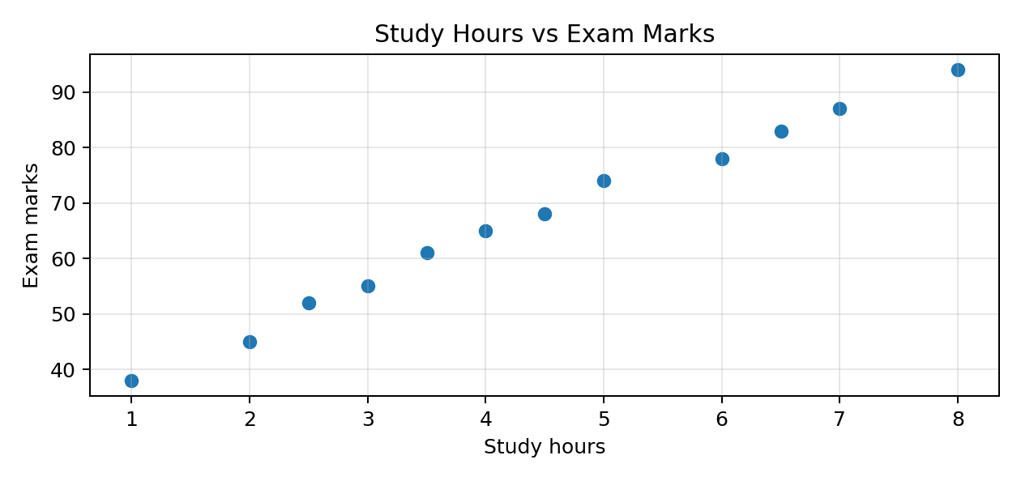
Figure 3. Example scatter plot showing study hours and exam marks.
Pattern | Meaning
Positive association | Larger X values tend to occur with larger Y values
Negative association | Larger X values tend to occur with smaller Y values
No clear association | No obvious linear pattern is visible

import matplotlib.pyplot as plt

study_hours = [1, 2, 2.5, 3, 3.5, 4, 4.5, 5, 6, 6.5, 7, 8]
marks = [38, 45, 52, 55, 61, 65, 68, 74, 78, 83, 87, 94]

plt.scatter(
study_hours,
marks,
color="darkorange",
marker="o",
label="Students"
)
plt.title("Study Hours vs Exam Marks")
plt.xlabel("Study hours")
plt.ylabel("Exam marks")
plt.legend()
plt.grid(True, alpha=0.3)
plt.show()

Correlation does not prove causation. A scatter plot may reveal an association, but other variables or coincidence may explain it.

6. Histogram
A histogram shows the frequency distribution of numerical data. It divides the value range into intervals called bins and displays how many observations fall into each interval.
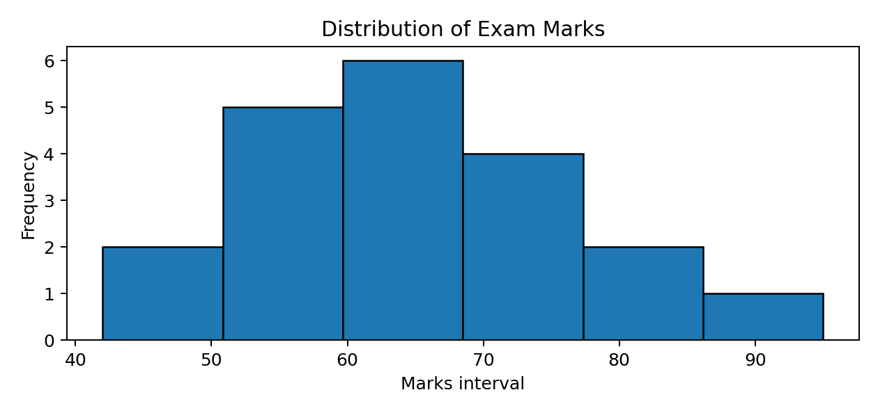
Figure 4. Example histogram of exam marks.
import matplotlib.pyplot as plt

marks = [42, 48, 51, 53, 55, 57, 58, 60, 61, 62,
64, 66, 68, 70, 72, 74, 76, 78, 81, 95]

plt.hist(
marks,
bins=6,
color="orange",
edgecolor="black"
)
plt.title("Distribution of Exam Marks")
plt.xlabel("Marks")
plt.ylabel("Frequency")
plt.show()

Parameter | Purpose
bins | Number of intervals or explicit bin edges
color | Fill color of bars
edgecolor | Border color
density=True | Normalize so the total area represents probability density
range | Limit the data range used for binning

Bin choice matters. Too few bins can hide structure; too many bins can make random variation look like meaningful detail. Histogram bars usually touch because the intervals represent a continuous numerical scale.

7. Box Plot and Outlier Detection
A box plot summarizes a numerical distribution using quartiles, the median, whiskers, and possible outlier points. It is useful for comparing spread and spotting observations that are far from the rest.
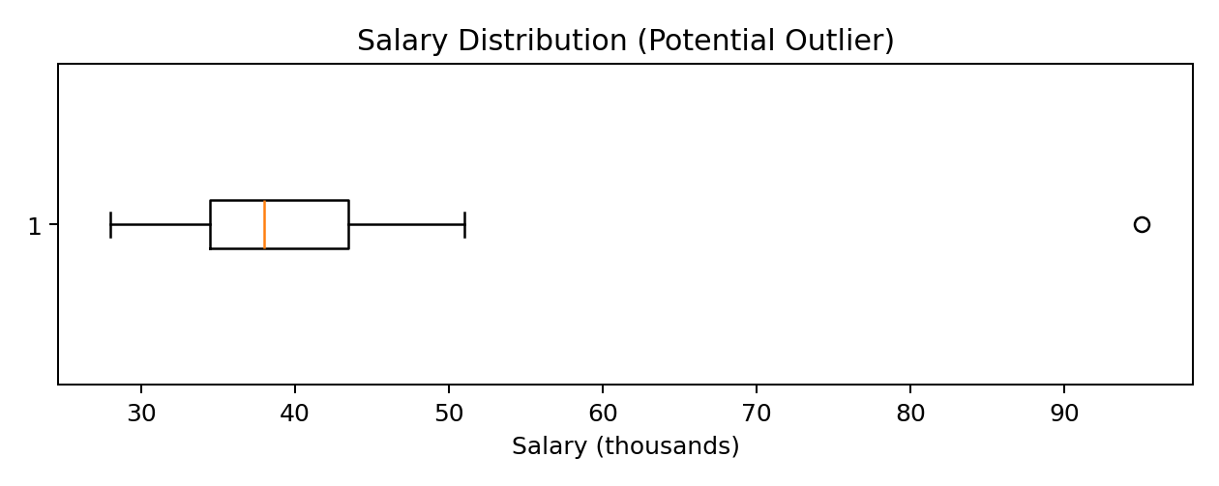
Figure 5. Example box plot; the isolated high value is flagged as a potential outlier.
Measure | Meaning
Minimum / lower whisker | Smallest non-outlier observation under the plotting rule
Q1 | 25th percentile
Median (Q2) | 50th percentile
Q3 | 75th percentile
Maximum / upper whisker | Largest non-outlier observation under the plotting rule
Outlier point | Observation plotted beyond the whisker limits

Important formulas
Interquartile range (IQR): IQR = Q3 − Q1
Lower fence: LF = Q1 − 1.5 × IQR
Upper fence: UF = Q3 + 1.5 × IQR
Values below LF or above UF are commonly flagged as potential outliers. A flagged value is not automatically an error; investigate its source and context.
import matplotlib.pyplot as plt

salary = [28, 31, 32, 34, 35, 36, 37, 38, 39, 41, 42, 45, 47, 51, 95]

plt.boxplot(salary)
plt.title("Salary Distribution")
plt.ylabel("Salary (thousands)")
plt.show()

8. Matplotlib vs Seaborn
Seaborn is a statistical data-visualization library built on Matplotlib. It provides a higher-level interface and works particularly well with Pandas DataFrames.
Matplotlib | Seaborn
Lower-level plotting interface | Higher-level statistical plotting interface
Fine-grained control over plot elements | Convenient defaults and statistical summaries
Works with lists, arrays and DataFrames | Integrates closely with DataFrames
Often requires more manual styling | Attractive themes and palettes are readily available
General-purpose plotting | Especially convenient for statistical exploration

Install and import
pip install seaborn

import seaborn as sns
import matplotlib.pyplot as plt

Seaborn scatter plot
import seaborn as sns
import matplotlib.pyplot as plt

tips = sns.load_dataset("tips")

sns.scatterplot(
data=tips,
x="total_bill",
y="tip",
hue="sex"
)

plt.title("Total Bill vs Tip")
plt.show()

The hue parameter assigns different visual colors to categories, helping compare groups within one chart.

9. Important Seaborn Visualizations
Function | What it displays | Typical use
sns.lineplot() | Line plot | Trends and ordered data
sns.barplot() | Statistical bar plot | Compare an aggregate across categories
sns.scatterplot() | Scatter plot | Relationship between two numerical variables
sns.histplot() | Histogram / distribution | Frequency distribution
sns.boxplot() | Box plot | Quartiles and potential outliers
sns.countplot() | Category counts | Number of records in each category
sns.heatmap() | Color-coded matrix | Correlation matrix or tabular intensity
sns.violinplot() | Distribution density by category | Compare distribution shapes
sns.pairplot() | Pairwise plots | Explore several numerical features
sns.regplot() | Scatter plus fitted regression line | Visualize a linear trend

Count plot
A count plot displays the number of observations in each category. It is useful for counts such as students per department or orders per product category.
import seaborn as sns
import matplotlib.pyplot as plt

tips = sns.load_dataset("tips")

sns.countplot(data=tips, x="day")
plt.title("Number of Records by Day")
plt.show()

Heatmap and correlation
A heatmap encodes values using color intensity. A common use is visualizing a correlation matrix for numerical columns.
import seaborn as sns
import matplotlib.pyplot as plt

tips = sns.load_dataset("tips")
numeric_data = tips.select_dtypes(include="number")
correlation = numeric_data.corr()

sns.heatmap(
correlation,
annot=True,
cmap="coolwarm",
fmt=".2f"
)
plt.title("Correlation Heatmap")
plt.show()

Pearson correlation coefficient: r = Cov(X, Y) / (σX × σY). Its value is between −1 and +1. A value near +1 indicates strong positive linear association; near −1 indicates strong negative linear association; near 0 indicates little or no linear association.

Pair plot
import seaborn as sns
import matplotlib.pyplot as plt

iris = sns.load_dataset("iris")
sns.pairplot(iris, hue="species")
plt.show()

A pair plot places pairwise relationships between numerical columns into a grid. It is useful during early exploratory data analysis, but can become crowded with many features.

Violin plot
import seaborn as sns
import matplotlib.pyplot as plt

tips = sns.load_dataset("tips")

sns.violinplot(
data=tips,
x="day",
y="total_bill"
)
plt.title("Bill Distribution by Day")
plt.show()

A violin plot combines a density shape with summary information. The width indicates where observations are more concentrated.

10. Subplots in Matplotlib
Subplots place multiple Axes inside one Figure. They help compare several views of the same dataset without opening separate figures.

plt.subplot()
Syntax: plt.subplot(number_of_rows, number_of_columns, position). The position is counted from left to right, then top to bottom, starting at 1.
import matplotlib.pyplot as plt

months = [1, 2, 3, 4, 5]
sales = [100, 150, 120, 200, 250]
expenses = [80, 100, 110, 130, 160]

plt.figure(figsize=(10, 8))

plt.subplot(2, 2, 1)
plt.plot(months, sales, marker="o")
plt.title("Monthly Sales")

plt.subplot(2, 2, 2)
plt.bar(months, expenses)
plt.title("Monthly Expenses")

plt.subplot(2, 2, 3)
plt.scatter(sales, expenses)
plt.title("Sales vs Expenses")

plt.subplot(2, 2, 4)
plt.hist(sales, bins=5)
plt.title("Sales Distribution")

plt.tight_layout()
plt.show()

plt.subplots()
plt.subplots() creates a Figure and its Axes together. The returned axes array can be indexed to customize each chart.
import matplotlib.pyplot as plt

months = [1, 2, 3, 4, 5]
sales = [100, 150, 120, 200, 250]

fig, axes = plt.subplots(2, 2, figsize=(10, 8))

axes[0, 0].plot(months, sales)
axes[0, 0].set_title("Line Plot")

axes[0, 1].bar(months, sales)
axes[0, 1].set_title("Bar Plot")

axes[1, 0].scatter(months, sales)
axes[1, 0].set_title("Scatter Plot")

axes[1, 1].hist(sales, bins=5)
axes[1, 1].set_title("Histogram")

fig.tight_layout()
plt.show()

plt.subplot() | plt.subplots()
Selects or creates one subplot position at a time | Creates a figure and its Axes objects together
Uses row, column and position arguments | Returns (fig, axes)
Convenient for quick/simple layouts | Convenient for systematic customization
Example: plt.subplot(2, 2, 1) | Example: fig, axes = plt.subplots(2, 2)

For a 2 × 2 axes array: axes[0, 0] is top-left, axes[0, 1] is top-right, axes[1, 0] is bottom-left, and axes[1, 1] is bottom-right.

11. Titles, Labels, Legends, Grid and Saving
Element | Function | Why it matters
Title | plt.title() | States the chart's subject
X-axis label | plt.xlabel() | Explains horizontal values
Y-axis label | plt.ylabel() | Explains vertical values
Legend | plt.legend() | Identifies separate plotted series
Grid | plt.grid() | Helps estimate values
Figure size | plt.figure(figsize=(w, h)) | Controls figure dimensions
Axis limits | plt.xlim() / plt.ylim() | Controls the visible range
Save | plt.savefig() | Exports the chart

import matplotlib.pyplot as plt

months = ["Jan", "Feb", "Mar", "Apr", "May"]
sales_2025 = [100, 150, 120, 200, 250]
sales_2026 = [120, 170, 160, 220, 280]

plt.figure(figsize=(9, 5))

plt.plot(months, sales_2025, marker="o", label="2025")
plt.plot(months, sales_2026, marker="s", label="2026")

plt.title("Sales Comparison", fontsize=16)
plt.xlabel("Month")
plt.ylabel("Sales")
plt.legend()
plt.grid(True, linestyle="--", alpha=0.4)
plt.xlim("Jan", "May")
plt.tight_layout()

plt.savefig("sales_comparison.png", dpi=300, bbox_inches="tight")
plt.show()

Use a meaningful title and units on axes. Do not truncate a bar-chart axis in a way that exaggerates differences. Save after layout adjustments and before or after show depending on the plotting environment; saving before show is a reliable common pattern.

12. Choosing the Correct Visualization
Question / Goal | Recommended chart | Reason
How does a value change over time? | Line plot | Shows ordered trends
Which category has the largest value? | Bar plot | Compares categories
How are two numerical variables related? | Scatter plot | Shows paired observations
How are numerical values distributed? | Histogram | Shows frequency by interval
Are there potential outliers? | Box plot | Shows quartiles and whisker limits
How many records are in each category? | Count plot | Counts category occurrences
How do many numerical features correlate? | Heatmap | Shows a matrix of coefficients
How do distributions differ by group? | Violin / box plot | Compares shape or summary

Quick decision guide
What is the main question?
|
+-- Trend over ordered time/sequence? ----> Line plot
|
+-- Compare categories? -----------------> Bar plot
|
+-- Count category observations? --------> Count plot
|
+-- Relationship between two numbers? ---> Scatter plot
|
+-- Distribution / frequency? ----------> Histogram
|
+-- Spread / possible outliers? ---------> Box plot
|
+-- Correlation matrix? -----------------> Heatmap

13. Practical Project — Student Performance Visualization
Objective: load student records from a CSV file, validate and clean the data, calculate average marks, compare departments and subjects, inspect distributions and relationships, and save chart reports.

Project structure
student_visualization/
|
|-- data/
| |-- students.csv
|
|-- reports/
|
|-- main.py
|-- requirements.txt

requirements.txt
pandas
numpy
matplotlib
seaborn

Sample data — data/students.csv
Student_ID,Name,Department,Python,AI,Maths
1,Aman,CSE,85,90,80
2,Rahul,AI,90,88,92
3,Simran,CSE,78,85,82
4,Harshit,AI,95,92,90
5,Neha,IT,80,75,85
6,Karan,IT,70,78,72
7,Priya,CSE,88,91,87
8,Arjun,AI,82,86,80
9,Riya,IT,92,89,94
10,Manav,CSE,75,80,78

Complete main.py
import os

import matplotlib.pyplot as plt
import pandas as pd
import seaborn as sns

class StudentVisualizationDashboard:
def __init__(self, file_path):
self.file_path = file_path
self.data = None
self.output_dir = "reports"
self.subjects = ["Python", "AI", "Maths"]

os.makedirs(self.output_dir, exist_ok=True)
sns.set_theme(style="whitegrid")

def load_data(self):
try:
self.data = pd.read_csv(self.file_path)

required_columns = [
"Student_ID",
"Name",
"Department",
"Python",
"AI",
"Maths"
]

missing = [
column
for column in required_columns
if column not in self.data.columns
]

if missing:
raise ValueError(f"Missing columns: {missing}")

print("Dataset loaded successfully.")

except FileNotFoundError:
print("Error: CSV file not found.")

except (pd.errors.ParserError, ValueError) as error:
print(f"Data error: {error}")

def clean_data(self):
if self.data is None:
return

self.data = self.data.drop_duplicates(subset=["Student_ID"])

for subject in self.subjects:
self.data[subject] = pd.to_numeric(
self.data[subject],
errors="coerce"
)

median_value = self.data[subject].median()
self.data[subject] = self.data[subject].fillna(median_value)
self.data[subject] = self.data[subject].clip(0, 100)

self.data["Average"] = self.data[self.subjects].mean(axis=1)
print("Data cleaning completed.")

def show_overview(self):
print("\nDataset overview")
print(self.data.head())

print("\nStatistical summary")
print(self.data.describe())

print("\nDepartment counts")
print(self.data["Department"].value_counts())

def save_plot(self, filename):
path = os.path.join(self.output_dir, filename)
plt.tight_layout()
plt.savefig(path, dpi=300, bbox_inches="tight")
plt.show()
plt.close()
print(f"Saved: {path}")

def plot_department_performance(self):
department_avg = self.data.groupby("Department")["Average"].mean()

plt.figure(figsize=(8, 5))
department_avg.plot(kind="bar")
plt.title("Average Performance by Department")
plt.xlabel("Department")
plt.ylabel("Average marks")
self.save_plot("department_performance.png")

def plot_subject_performance(self):
subject_avg = self.data[self.subjects].mean()

plt.figure(figsize=(8, 5))
plt.plot(
self.subjects,
subject_avg,
marker="o",
linewidth=2,
label="Average marks"
)
plt.title("Subject-wise Average Performance")
plt.xlabel("Subject")
plt.ylabel("Average marks")
plt.legend()
self.save_plot("subject_performance.png")

def plot_subject_relationship(self):
plt.figure(figsize=(8, 5))
sns.scatterplot(
data=self.data,
x="Python",
y="AI",
hue="Department",
s=100
)
plt.title("Python vs AI Performance")
self.save_plot("subject_scatter.png")

def plot_marks_distribution(self):
plt.figure(figsize=(8, 5))
sns.histplot(
data=self.data,
x="Average",
bins=5,
kde=True
)
plt.title("Student Average Marks Distribution")
plt.xlabel("Average marks")
plt.ylabel("Number of students")
self.save_plot("marks_distribution.png")

def plot_outliers(self):
plt.figure(figsize=(8, 5))
sns.boxplot(data=self.data[self.subjects])
plt.title("Subject-wise Marks Distribution")
plt.ylabel("Marks")
self.save_plot("marks_boxplot.png")

def plot_correlation(self):
numeric_columns = self.subjects + ["Average"]
correlation = self.data[numeric_columns].corr()

plt.figure(figsize=(8, 6))
sns.heatmap(
correlation,
annot=True,
cmap="coolwarm",
fmt=".2f"
)
plt.title("Student Performance Correlation")
self.save_plot("correlation_heatmap.png")

def save_cleaned_data(self):
output_path = os.path.join(
self.output_dir,
"cleaned_students.csv"
)
self.data.to_csv(output_path, index=False)
print(f"Cleaned data saved: {output_path}")

def run(self):
self.load_data()

if self.data is None:
return

self.clean_data()
self.show_overview()

self.plot_department_performance()
self.plot_subject_performance()
self.plot_subject_relationship()
self.plot_marks_distribution()
self.plot_outliers()
self.plot_correlation()

self.save_cleaned_data()
print("\nDashboard analysis completed.")

if __name__ == "__main__":
dashboard = StudentVisualizationDashboard("data/students.csv")
dashboard.run()

Run the project
pip install -r requirements.txt
python main.py

Expected generated reports
reports/
|-- department_performance.png
|-- subject_performance.png
|-- subject_scatter.png
|-- marks_distribution.png
|-- marks_boxplot.png
|-- correlation_heatmap.png
|-- cleaned_students.csv

Project notes: the example fills missing numerical marks with each subject's median, removes duplicate Student_ID values, and clips marks to 0–100. These are demonstration decisions; a real project should validate whether clipping or filling is appropriate. A saved-chart report is not an interactive web dashboard.

14. Common Mistakes to Avoid
- Choosing a chart that does not match the question being asked.
- Leaving out a title, axis labels, units, or a legend when they are needed.
- Using too many colors, decorations, or visual effects.
- Choosing too few or too many histogram bins.
- Treating a potential outlier as an error without investigating it.
- Using a misleading axis scale, especially in bar charts.
- Allowing subplot titles or labels to overlap; use tight_layout() or constrained layout.
- Assuming correlation proves cause and effect.
- Forgetting to close figures in scripts that create many charts.

15. Quick Revision — Key Differences
Comparison | First | Second
Bar plot vs Histogram | Categories; bars often have gaps | Numerical intervals; bars generally touch
Line vs Scatter | Connects ordered observations | Shows separate paired observations
Histogram vs Box plot | Shows distribution shape and frequencies | Summarizes quartiles, median and potential outliers
Matplotlib vs Seaborn | General low-level control | High-level statistical plotting interface
subplot vs subplots | Select/create one subplot position | Create figure and axes together

16. Important Formulas
Concept | Formula / definition
Mean | x̄ = (Σ xi) / n
Range | Maximum − Minimum
Interquartile range | IQR = Q3 − Q1
Lower fence | LF = Q1 − 1.5 × IQR
Upper fence | UF = Q3 + 1.5 × IQR
Pearson correlation | r = Cov(X, Y) / (σX × σY)
Histogram frequency | Number of observations inside a bin

Correlation coefficient interpretation: +1 is perfect positive linear correlation; −1 is perfect negative linear correlation; 0 means no linear correlation (but a nonlinear relationship may still exist).

17. Interview / Viva Questions
What is data visualization?
Representing data graphically to understand patterns, comparisons, relationships and distributions.
What is Matplotlib?
A Python plotting library for creating static, animated and interactive visualizations.
What is Seaborn?
A statistical visualization library built on Matplotlib, with a high-level interface.
When should you use a line plot?
When the x-axis has a meaningful order and the goal is to show a trend.
When should you use a bar plot?
When comparing numerical values across discrete categories.
What is a scatter plot used for?
Exploring the relationship between two numerical variables.
What is a histogram?
A chart showing numerical frequency distribution using bins.
What is a box plot?
A statistical summary showing quartiles, median, whiskers and potential outliers.
What is IQR?
The difference between the third quartile and first quartile.
What is an outlier?
An observation unusually far from the general pattern; it should be investigated.
What is hue in Seaborn?
A parameter that separates categories using different colors.
What is a heatmap?
A matrix-like visualization where values are represented by color intensity.
What is a count plot?
A chart that displays the number of observations in each category.
What is a pair plot?
A grid of pairwise plots used to explore relationships among numerical features.
What is a violin plot?
A plot that visualizes distribution density across categories.
What is the difference between subplot() and subplots()?
subplot() selects/creates a position; subplots() creates a figure and its axes together.
What does tight_layout() do?
Adjusts spacing to reduce overlap between plot elements.
What does savefig() do?
Saves a figure to a file such as PNG or PDF.
Can correlation prove causation?
No. Correlation indicates association, not proof of cause and effect.
Which chart is useful for potential outlier detection?
A box plot is a common first choice.

18. Coding Practice
- Create a line plot showing temperature changes over seven days.
- Create a bar chart comparing marks of five students.
- Create a horizontal bar chart showing sales by product.
- Create a grouped bar chart comparing Python and AI marks.
- Create a scatter plot showing study hours against marks.
- Generate 100 random marks and visualize them with a histogram.
- Create a box plot for salary data and identify potential outliers.
- Create four plots in one figure using plt.subplot().
- Recreate the four plots using plt.subplots().
- Load a Pandas DataFrame and create a Seaborn correlation heatmap.
- Create a pair plot using the Iris dataset.
- Extend the student dashboard with a count plot of students by department.

19. Day 386 Completion Checklist
- ☐ Understand the purpose and workflow of data visualization.
- ☐ Revise Matplotlib installation, figures, axes and common functions.
- ☐ Create and interpret line plots.
- ☐ Create vertical, horizontal, grouped and stacked bar charts.
- ☐ Create scatter plots and explain correlation carefully.
- ☐ Create histograms and understand bins.
- ☐ Interpret box plots, quartiles, IQR and potential outliers.
- ☐ Use Seaborn for statistical visualizations.
- ☐ Create count plots, heatmaps, pair plots and violin plots.
- ☐ Create multi-chart layouts using subplot() and subplots().
- ☐ Customize titles, labels, legends, grids, limits and saved output.
- ☐ Choose a visualization based on the analytical question.
- ☐ Build and run the Student Performance Visualization project.
- ☐ Complete coding practice and interview questions.

20. Learning Outcomes
After completing this revision, you should be able to:
- Create common charts using Matplotlib and Seaborn.
- Choose a chart based on data type and analysis goal.
- Compare categories, inspect trends and explore numerical relationships.
- Interpret distributions, quartiles and potential outliers.
- Arrange multiple charts in one figure.
- Customize and export readable visualizations.
- Build a small data-analysis report from a CSV dataset.
Next recommended topic: Day 387 — Exploratory Data Analysis (EDA) Complete Revision: data understanding, cleaning, descriptive statistics, univariate, bivariate and multivariate analysis, correlation, outlier detection and insight generation.

